**Project Planning PhaseSprint Delivery Plan**

# Product Backlog, Sprint Schedule, and Estimation (4 Marks)

## Sprint

Sprint-1

## Functional Requirement (Epic)

login

**User Story Number** USN-1

## User Story / Task

As a Administrator, I need to give user id and passcode for ever workers over there in municipality .

## Story Points

10

## Priority

High

## Team Members

Vyoyula manoja

parvathi

seetha, swathi

,Sprint-1

Sprint-2

Sprint-3

Sprint-4

Login

Dashboard

Dashboard

Dashboard

USN-2

USN-3

USN-4

USN-5

As a Co-Admin, I’ll control the waste level by monitoring them vai real time web portal.

Once the filling happens, I’ll notify trash truck with location of bin with bin ID

As a Truck Driver, I’ll follow Co-Admin’s Instruction to reach the filling bin in short roots and save time

As a Local Garbage Collector, I’II gather all the waste from the garbage, load it onto a garbage truck, and deliver it to Landfills

As a Municipality officer, I'll make sure everything is proceeding as planned and without any problems

10 High

20 medium

20 Medium

High

Vyoyula manoja,seetha,parvathi, swathi

Vyoyula manoja,seetha,parvathi,swathi

Vyoyula manoja,seetha,parvathi,swathi

Vyoyula manoja,seetha,parvathi,swathi

**Project Tracker, Velocity & Burndown Chart: (4 Marks)**

|  |  |  |  |  |  |  |
| --- | --- | --- | --- | --- | --- | --- |
| **Sprint** | **Total Story Points** | **Duration** | **Sprint Start Date** | **Sprint End Date (Planned)** | **Story Points Completed (as on Planned End Date)** | **Sprint Release Date (Actual)** |
| Sprint-1 | 20 | 6 Days | 24 Oct 2022 | 29 Oct 2022 | 20 | 30 Oct 2022 |
| Sprint-2 | 20 | 6 Days | 31 Oct 2022 | 05 Nov 2022 | 30 | 3 NOV 2022 |
| Sprint-3 | 20 | 6 Days | 07 Nov 2022 | 12 Nov 2022 | 49 | 6 NOV 2022 |
| Sprint-4 | 20 | 6 Days | 14 Nov 2022 | 19 Nov 2022 | 50 | 9 NOV 2022 |

Velocity:

Imagine we have a 10-day sprint duration, and the velocity of the team is 20 (points per sprint). Let’s calculate the team’s average velocity (AV) per iteration unit (story points per day)

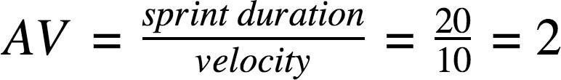

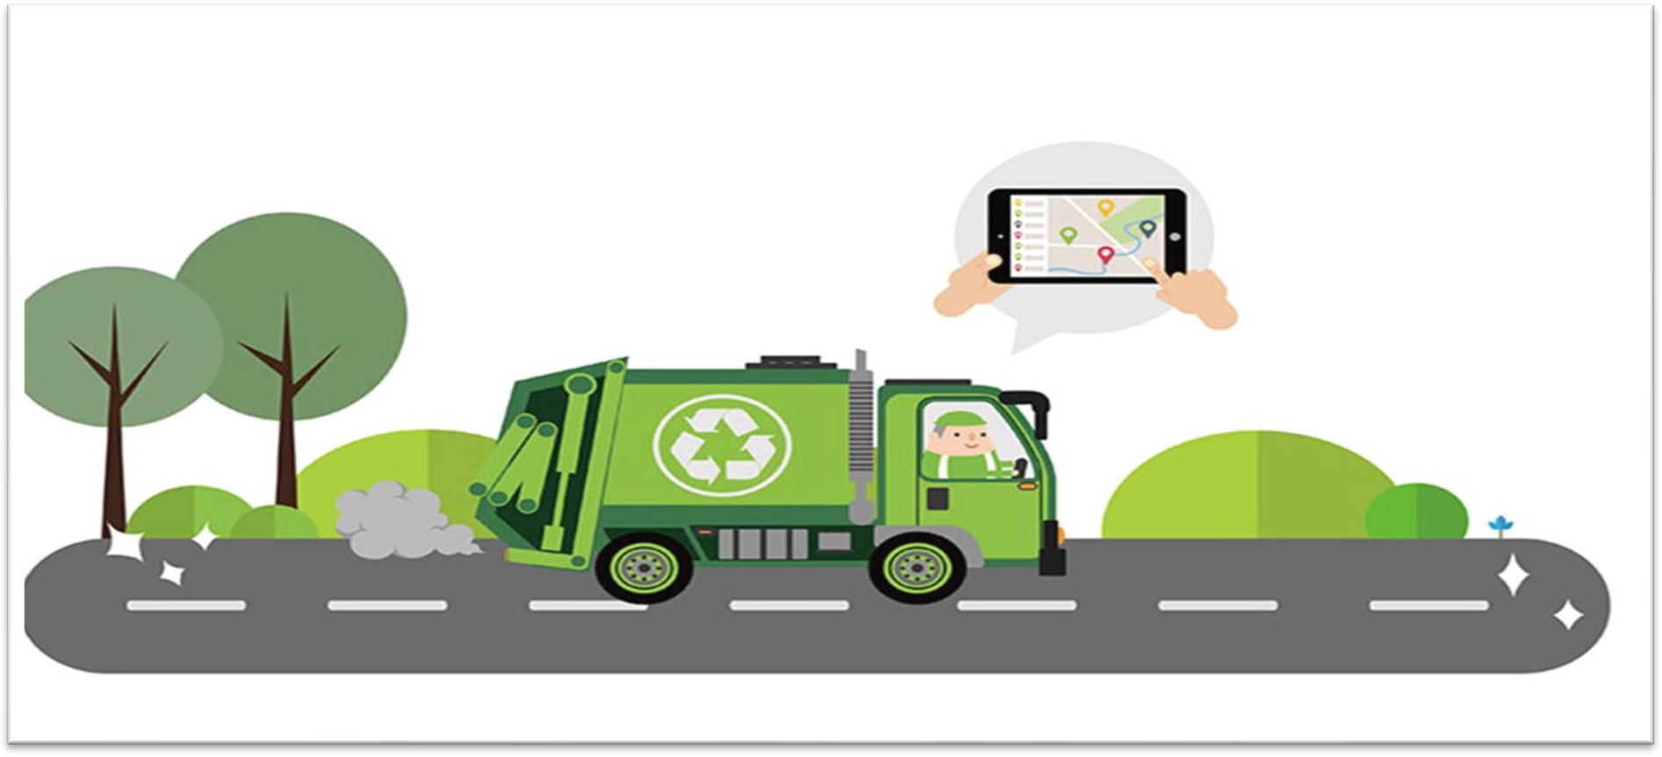

# THANK YOU